Php with mongodb

Step1:

Copy php_mongo.dll file to the following path

C:\xampp\php\ext

Step2:

Now we need to edit the confifuration file,the path of the same file is:

Xampp->php->find file type:configuration setting then open with wordpad that is where all these changes occur

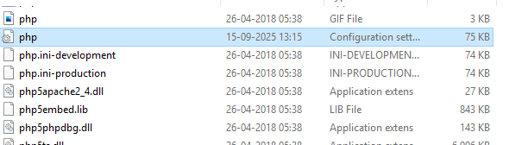

Use ctrl+f to find then a small window appears stating find what type extension there and then find this line

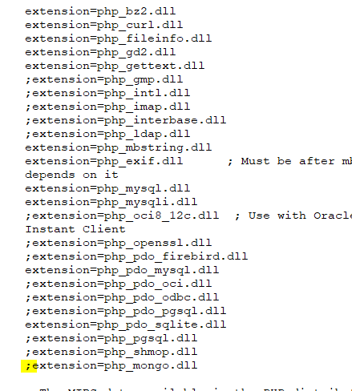

Add semicolon

Then copy this and paste here without semicolon

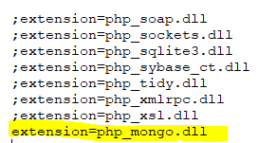

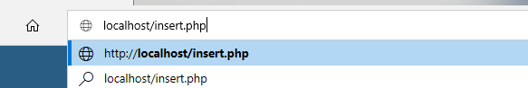

Open the

Step3: type the php code in a notepad and save this the location

C:/xampp/htdocs

To open the files open xampp window where we are supposed to select Apache server by clicking on start and admin button

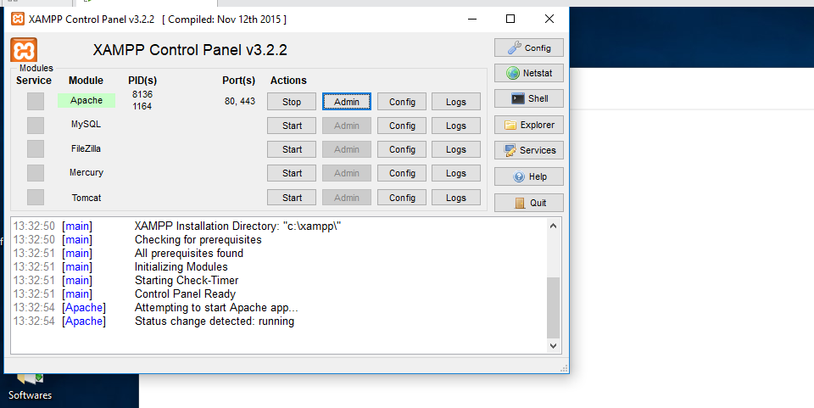

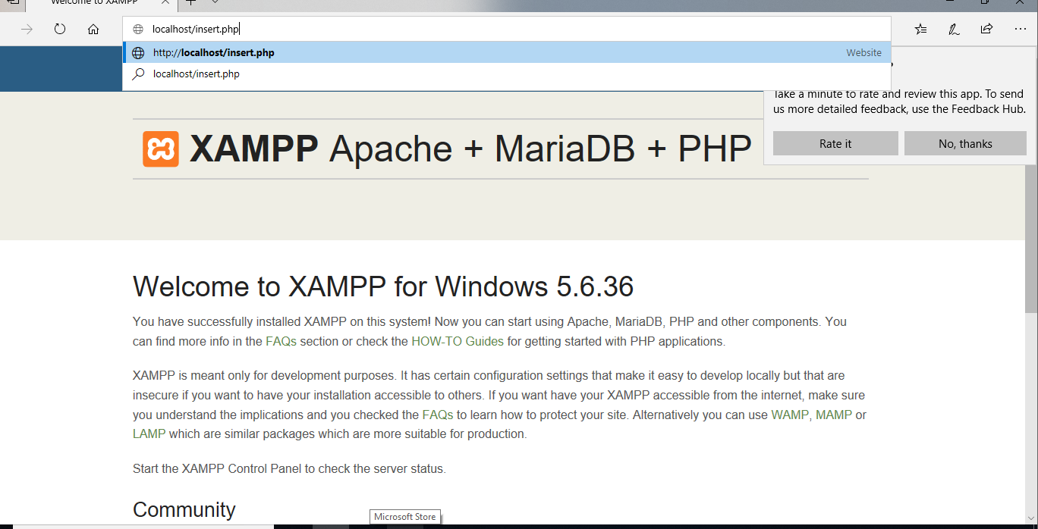

In the browser we need to edit the address bar by typing the file name after the local host/filename.php

